Result Explanation

Dataset Link

Used Dataset

<https://drive.internxt.com/s/file/9702fd7f680e28bbda38/9f80a3e4efe94acaf8ddc112c83be1be97722f386f86a8f490518f95d292ac13>

Entire Dataset

<https://www.kaggle.com/datasets/stoicstatic/face-recognition-dataset>

Image Data Scan (Train+Test Data)



Scanned Classes (Training Dataset)

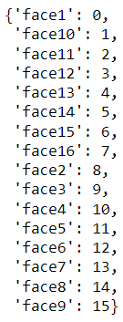

Different Expression in Single Class of Image(Sample)

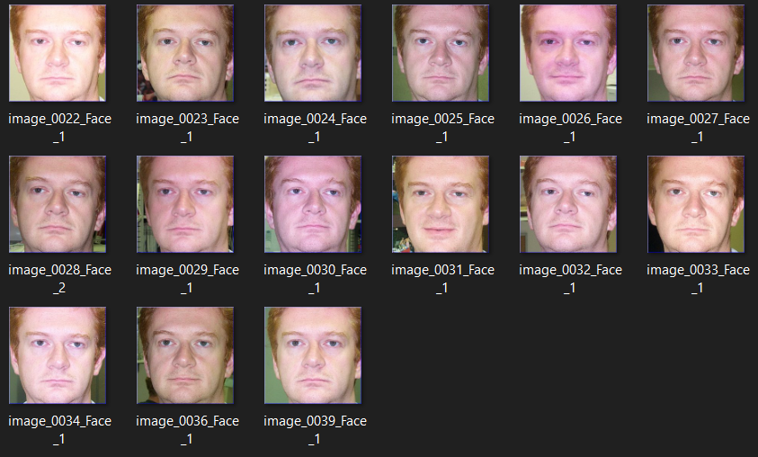

Mapping and Label ID



Converting Data into NumPy Array Format

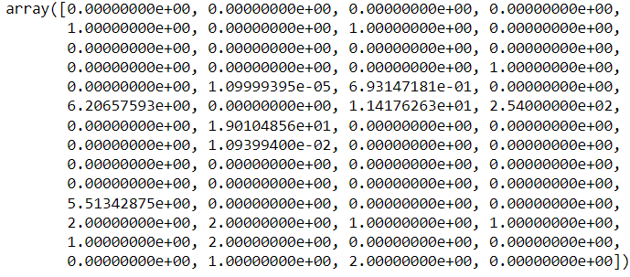

Normalizing Data for BPCNN



Model Summery BPCNN

Model: "bpcnn"

_________________________________________________________________

Layer (type) Output Shape Param #

=================================================================

conv2d_4 (Conv2D) (None, 60, 60, 16) 1216

max_pooling2d_4 (MaxPooling (None, 30, 30, 16) 0

2D)

conv2d_5 (Conv2D) (None, 26, 26, 64) 25664

max_pooling2d_5 (MaxPooling (None, 13, 13, 64) 0

2D)

flatten_2 (Flatten) (None, 10816) 0

dense_4 (Dense) (None, 64) 692288

dense_5 (Dense) (None, 16) 1040

=================================================================

Total params: 720,208

Trainable params: 720,208

Non-trainable params: 0

_________________________________________________________________

=================================================================

Model Execution

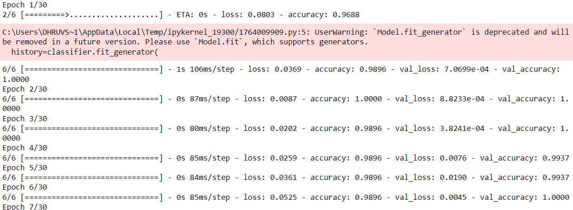

Model’s Measured Parameters



Model’s Accuracy/Loss Graphs

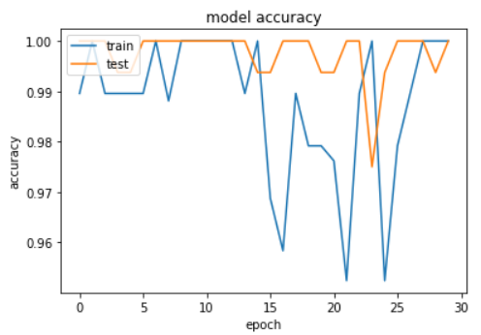 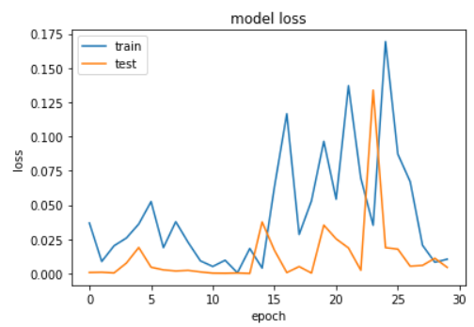

Shape and Class of Normalize Testing and Prediction Data





Test and Prediction Data

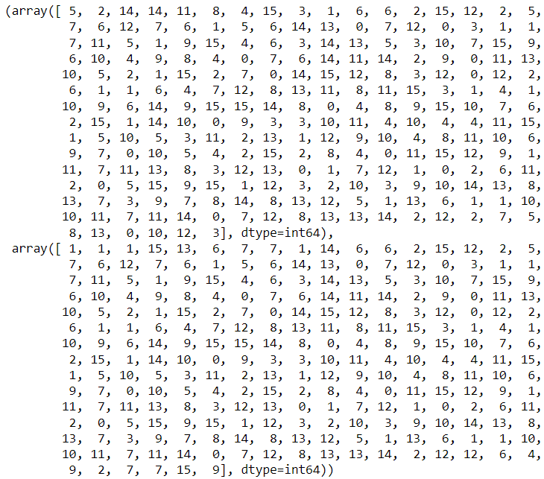

BCNN’s Classification Report

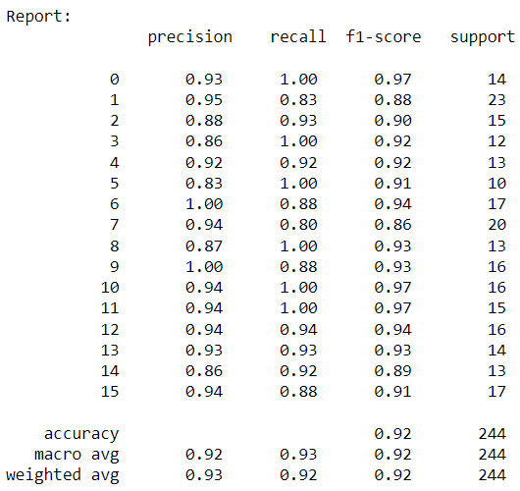

Model’s Scores

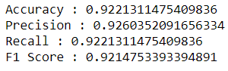

Mean Square Error/Mean Absolute Error of Model



Confusion Matrix

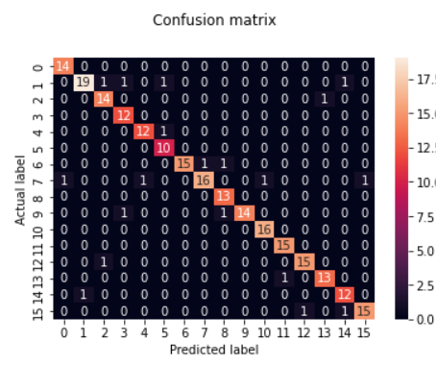

AUC/ROC Curve Score



Testing Single Image Prediction

Input

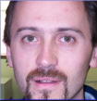

Test Scan BCNN



Prediction



Actual Image

